**Ideation Phase**

**Define the Problem Statements**

|  |  |
| --- | --- |
| Date | 19 September 2022 |
| Team ID | PNT2022TMID07118 |
| Project Name | Project - A Gesture-based Tool for Sterile Browsing of Radiology Images |
| Maximum Marks | 2 Marks |

**Customer Problem Statement Template:**

Create a problem statement to understand your customer's point of view. The Customer Problem Statement template helps you focus on what matters to create experiences people will love.

A well-articulated customer problem statement allows you and your team to find the ideal solution for the challenges your customers face. Throughout the process, you’ll also be able to empathize with your customers, which helps you better understand how they perceive your product or service.

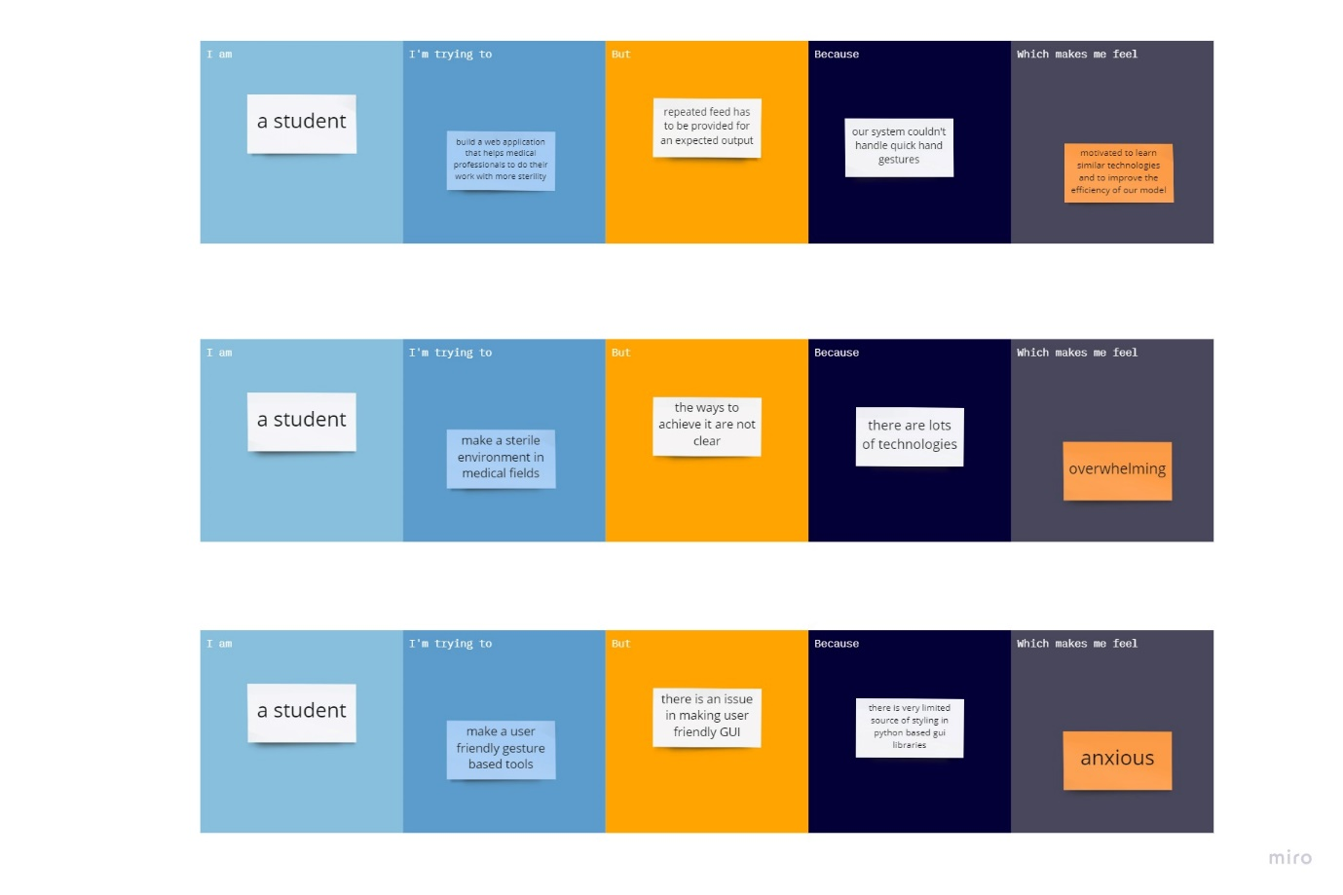

|  |  |  |  |  |  |
| --- | --- | --- | --- | --- | --- |
| **Problem Statement** | **I am** | **I’m trying to** | **But** | **Because** | **Which makes me feel** |
| PS-1 | a student | build a web application that helps medical professionals to do their work with more sterility | repeated feed has to be provided for an expected output | our system couldn't handle quick hand gestures | motivated to learn similar technologies and to improve the efficiency of our model |
| PS-2 | a student | make a sterile environment in medical fields | the ways to achieve it are not clear | there are lots of technologies | overwhelming |
| PS-3 | a student | make a user friendly gesture based tools | there is an issue in making user friendly GUI | there is very limited source of styling in python based GUI libraries | anxious |